

**Machine Learning**

**Homework 1**

Submitted by

**Manahil Sabir | 52904**

**Task 1**

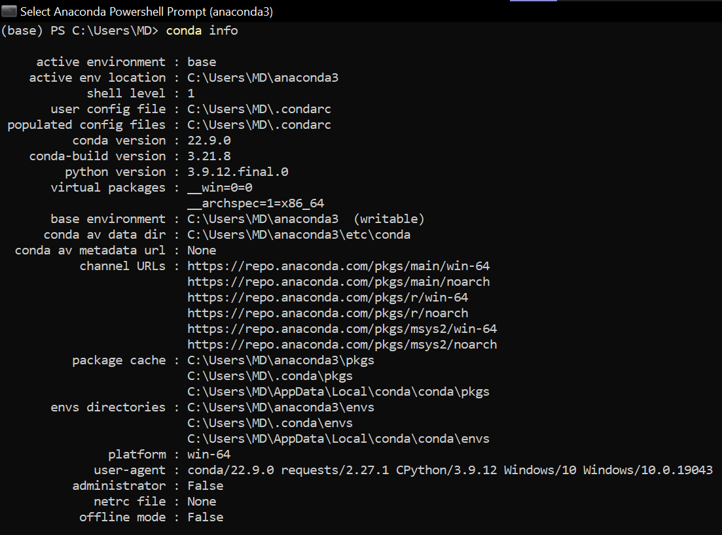

**Task 2**

**Task 3**

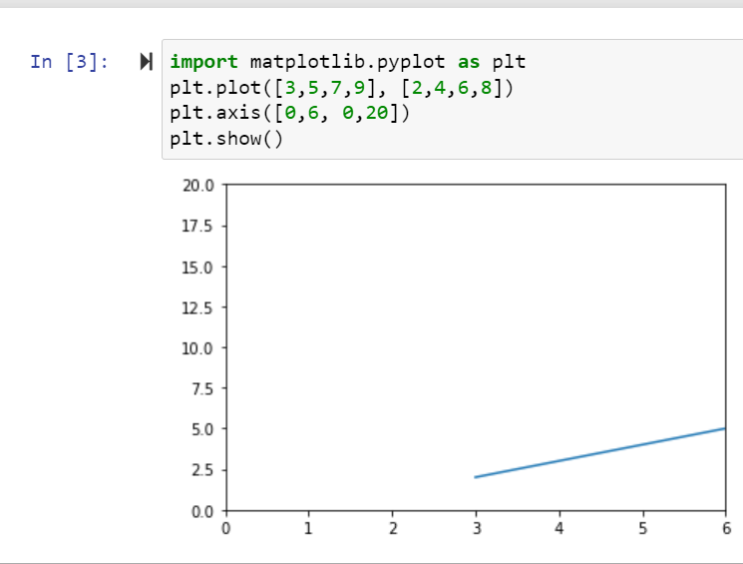

**Task 4**

<https://github.com/minni-developer/machine-learning.git>

